Kth largest element in a stream of running integers
Problem Statement: Implement a class KthLargest to find the kth largest number in a stream. It should have the following methods:
• KthLargest(int k, int [] nums) Initializes the object with the integer k and the initial stream of numbers in nums
• int add(int val) Appends the integer val to the stream and returns the kth largest element in the stream.
Note that it is the kth largest element in the sorted order, not the kth distinct element.
Input: [KthLargest(3, [1, 2, 3, 4]), add(5), add(2), add(7)]
Output: [null, 3, 3, 4]
Explanation: initial stream = [1, 2, 3, 4], k = 3. add(5): stream = [1, 2, 3, 4, 5] -> returns 3 add(2): stream = [1, 2, 2, 3, 4, 5] -> returns 3 add(7): stream = [1, 2, 2, 3, 4, 5, 7] -> returns 4
Algorithm
To keep track of the kth largest element in real-time, we don’t need to sort the entire list each time. Instead, we can maintain a Min-Heap of size k. This way, the top of the heap always gives us the kth largest element so far. Each time a new element is added, we check if it’s large enough to enter the heap. If it is, we add it and remove the smallest to maintain only the top k elements.
- Create a min-heap.
- Insert the first k elements from the initial stream into the heap.
- For the remaining elements in the initial stream:
  - If the element is greater than the smallest in heap, insert it and remove the smallest.
- When a new element is added via add()
  - Insert it into the heap.
  - If heap size exceeds k, remove the smallest.
  - Return the top of the heap (kth largest).
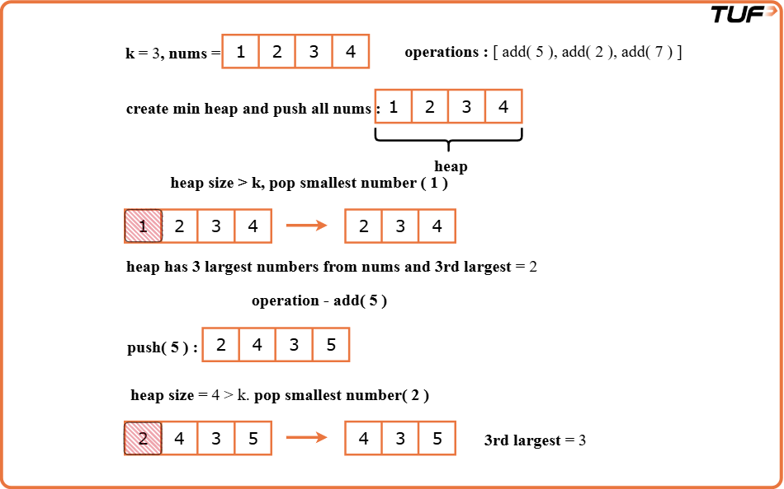

class Solution {
// Min-heap to store top k elements
PriorityQueue<Integer> minHeap;
int size;

// Constructor to initialize heap with initial elements
public Solution(int k, int[] nums) {
size = k;
minHeap = new PriorityQueue<>();

// Add numbers to heap
for (int num : nums) {
minHeap.offer(num);

// If heap exceeds k, remove the smallest
if (minHeap.size() > k) {
minHeap.poll();
}
}
}

// Adds new value to stream and returns k-th largest
public int add(int val) {
// Add new element
minHeap.offer(val);

// Maintain size of k
if (minHeap.size() > size) {
minHeap.poll();
}

// Return root (k-th largest)
return minHeap.peek();
}
}
Time Complexity: O(log k), per insertion each insertion into the min-heap takes O(log k) time. Since we maintain a heap of at most k elements, both inserting a new number and removing the smallest (if needed) are log k operations.
Space Complexity:O(k),The min-heap stores only the top k largest elements at any time. So space usage is proportional to k.

